Final Project Rubric

 | 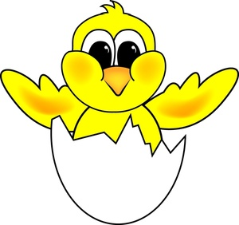  Beginner | Getting there | Best
Vocabulary | Use only the original story charcters | Use less than 3 animals charcters in additon to the orignal charcters. | Use 3 or more animal chacters in additon to the orignal charcters.
Speaking | Students recall three charcters | Recall all the charcters in the story | Retell the story.
Apperance | The product is not clear | The pruduct is clear | The pruduct is clear and nice looking

