CAST’s UDL LESSON BUILDER

Lesson Overview
Title: | The very big carrot
Author: | Amna AlHammadi
Subject: | EFL
Grade Level(s): | Kindergarten
Subject Area: | Listening, speaking and vocabulary
Unit Description:
This lesson is a part of a unit that focus on identifying animals. In this unit, the students will be interduced to a story, which is an adaptation for The Enormous Turnip, and will learn the animals in the story. They will have the opportunity to retell the story on their words. The students then will be introduced to animal songs that includes different sets of animals name, and are going to be encaged in various activities to support learning the animals names (by hear and point, and see and say). Students list of animal word idntification will be depending on their interest and effort, so some studens will be able to memorize more wrods than their classmates. As a final project the students will be asked to adapt The Very Big Carrot story using different animals. The will be given the opportunity to chose any mean to achieve the task. (e. g. create poster and share/ create video/ play)
Lesson Description for Day:
In this lesson the students will be learning to idnitify othre animals than the story charcters and practice the new vocaburaly.

Goals
Unit Goals: | 1. Students will be able to idintify the characters.  2. Students will be able to disscus the moral of the story (helping).  3. Students will be able to idinify the new vocabulary (animals)  4. Students wil be able to retell the story  5. Students will be able to modify the story and add different or more characters.
Lesson Goals: | - Students hear a word (animal) and tell wich picture or opbject is for it.  - Students see a picture or an object ans ssay the word for it.  The main task is to mentain his interest and attention as much as he can to be able to idintify at least 3 animals at the end of the session.

Methods
Anticipatory Set: | Inform the students about the objective of the lesson which is learning new animals names. Share with them the order of the activities: brainstorm, listen to a song and name the animals, share them in with the class, choose some animals and practice in the centers.  Students with ADHD learn best with stractured lesson. It is important for the teacher to prepare the student of the objective of the lesson and of what is expected of him to do. http://www2.ed.gov/rschstat/research/pubs/adhd/adhd-teaching_pg3.html .  Use Popplet to brainstorm name of animals they already know in English. Poppet is encaging because we cand drow or add pictures and videos. Have the students to mimic the sound and act like the animals they suggeseted.  This techneque will help the student to review previous lesson. Popplet allows multimidia, which attracted Abdulla as well as data-show projecter. Teacher can ask Abdulla to choose the students who will like to say what animal teacher should put in the Popplet. Abdulla can press a stress ball if he felt board. Poppet also allows using different colors which is good to orgainzie and supperate prior and new information.
Introduce and Model New Knowledge: | Pre-listening: Ask the studetns to listen for animals names and memorize it. Play the song.  Post-listeining: try to remember and name the animals in the songs. Add the animals in the Popplet. Add pictures or videos, and mimic the sounds and action of the animals with the students.  Abdulla enjoys songs very much, and he can keep his attention for 5 minutes. He might not be able to remember any animal during listening, but reviewing the wrods with students, showing picutes and videos and acting out action and sound helps him to learn. He can use the stress ball if he felt boared.
Provide Guided Practice: | Give students Samsong Tablets that include 4 songs about animals as well as appliations games Incorage the students to listen to the songs or play the games, and have them to disscus what animal they remember from the songs and the games. They can disscus on pairs or groups.  Students share the name of the animals and add it on the Popplet with the help of the teacher.  In EFL, exposure to the language is very important. Since students can’t read in English yet, listining is the only receptive skill they can use. This is why songs and games with audio is provided. The students can practice the words more by sharing them, looking at pictures, watchin videos, mimicing animals sounds and actions.  Use Eggtimer webstie to time the activities (guided and independent practice). The students as well as Abdulla should be able to work during the time. Abdulla will knows that it is a working time and he need to foucses more on the task.  Abdulla will most likely prefere to work alone at first, but he won’t mind disscussing with his close friend, and the others in the group. He will be less likely to get boared.  If he gets distructed it would be because he is ingross in the song and the game. He might not be able to achieve the task, so he will be needed more teacher guidness.
Provide Independent Practice: | Give the students the option to work indiviuly, in pairs or in groups. The centers seperated by colors, each students take a colored card and go to the center. There should be 5 in each Center, but students can move to other center if they finished the activity in the first center.  - Center 1 (Make a picture book): provide materials (papers, animals pictures, crayons,siccesrs, glues, stabblers, etc). After finishing the students publish their book by showing their mates and saying what animal they included in their book.  - Center 2 (Role play): students mimic an animal and the rest of animals try to guess what animal is chosen. Students choose animal as their charchter and play a story.  - Center 3 (Memory games cards): ): Provide materials (cards, animals pictures,siccesrs, glues). Students stick picture in one side. Two cards should have the same picture. After finishing students can play togather.  - Center 4 (Create a video): Students use Com-phone application on Samsung to creat a video by uploading pictures and sounds.  Abdulla will most likely choose center 2 or center 4, he loves technology. He will need more support than the other students. Once he get bored he can go the classroom computer to play online game or listen to the songs again.  Abdulla will be given the opprotonity to take small break if he wished too. He will be giving a timer, so he knows he should come back when the timer rings. If he wish, he can go and stand up near a wall if he can’t sit on

Assessment
Formative/Ongoing Assessment: | Monitor students during the practice stages; ask them what animal they choose to include in their work. Point out to pictures ask them what animal is this? Correct any errors.
Summative/End Of Lesson Assessment: | The students could show their products, or say all the animals they memorize.  The main summatiave assesmetn will be used in the unit last session; as students going to create a modified story of the Very big carrot story, using any productive methode of ther choice. (video, book, poster, gologster, play, etc)

Materials
Activity train (advance organizer)
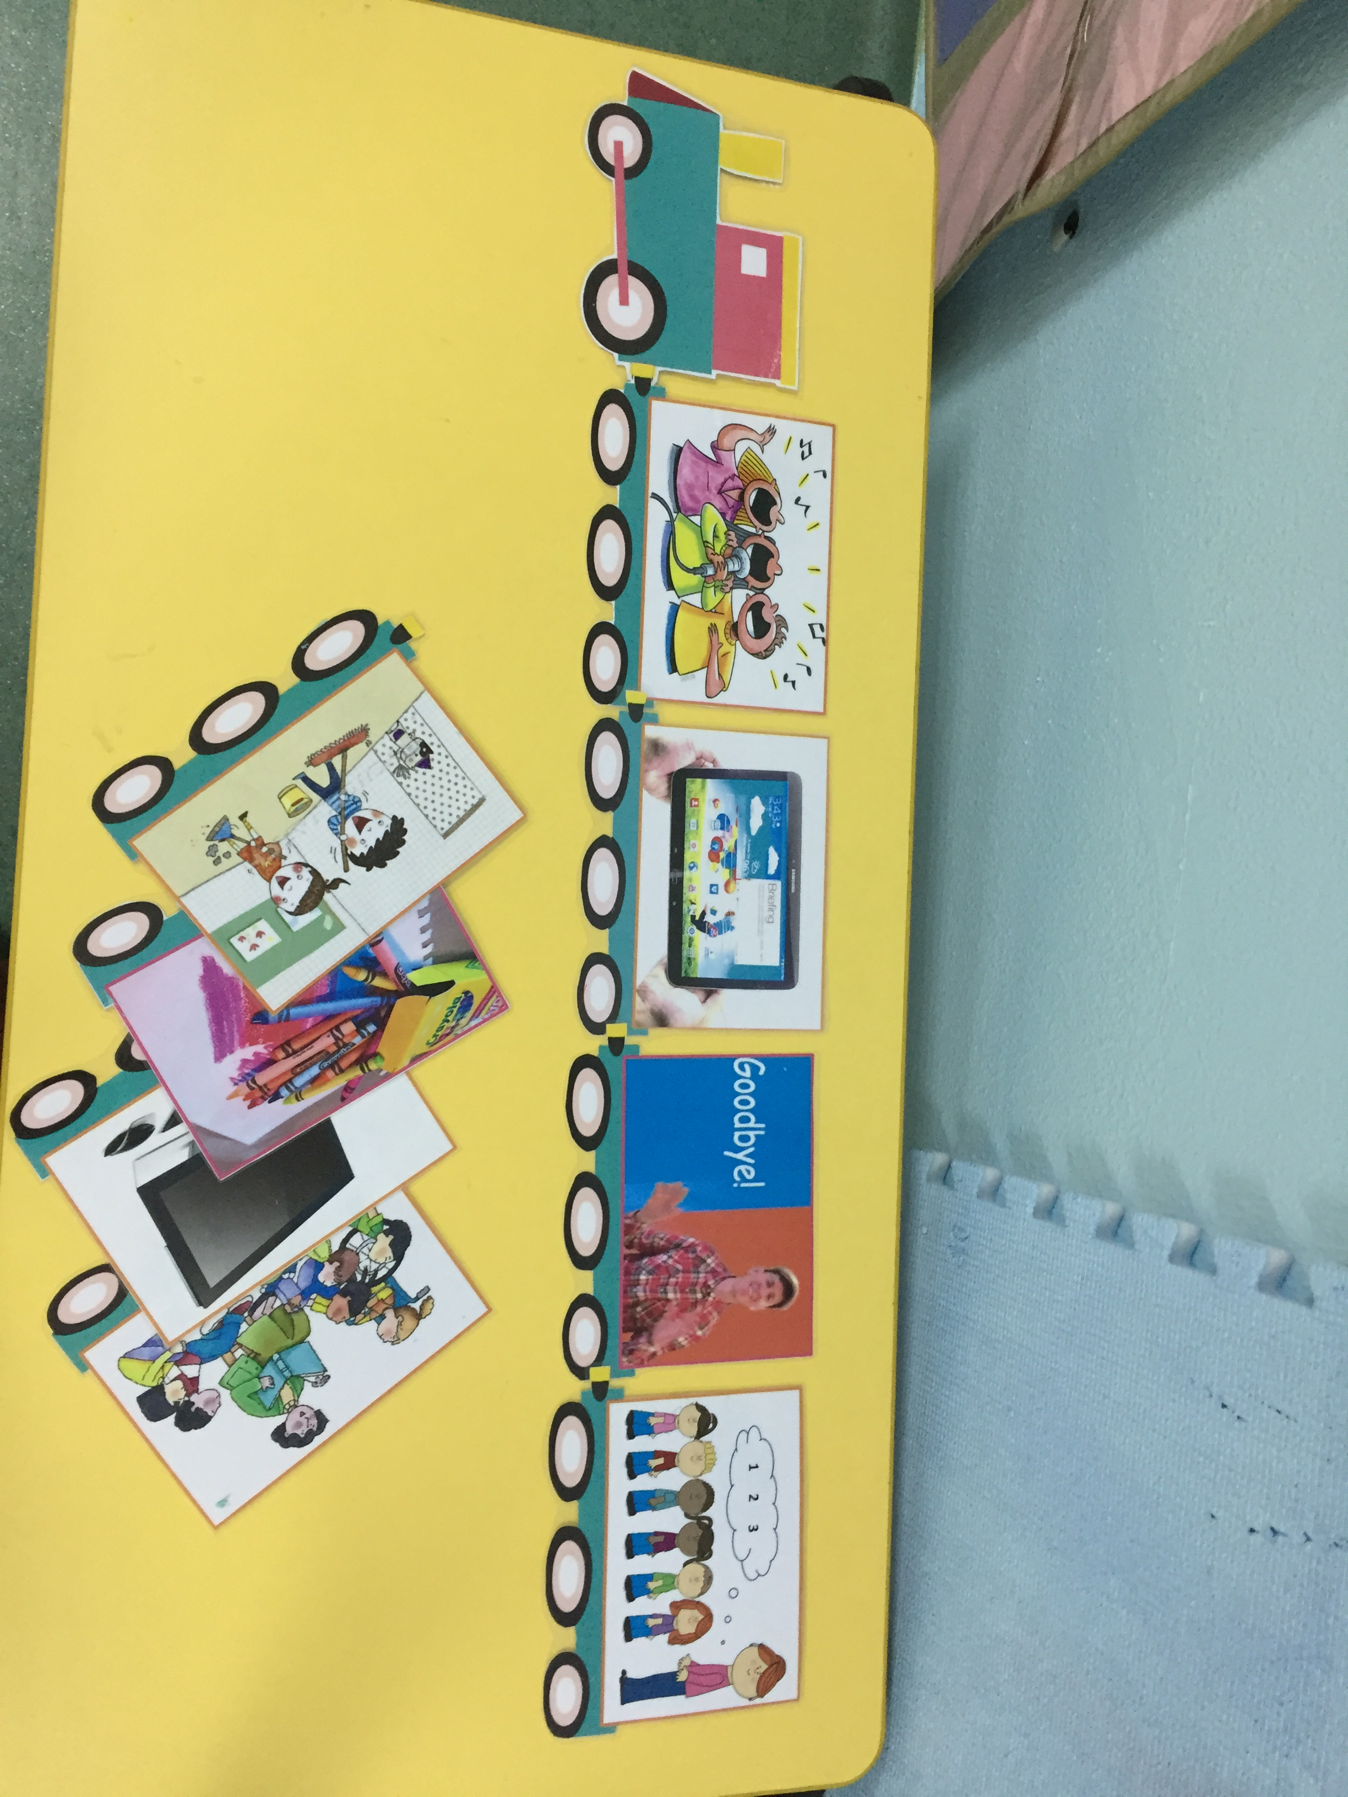
Mind mapping website: http://popplet.com
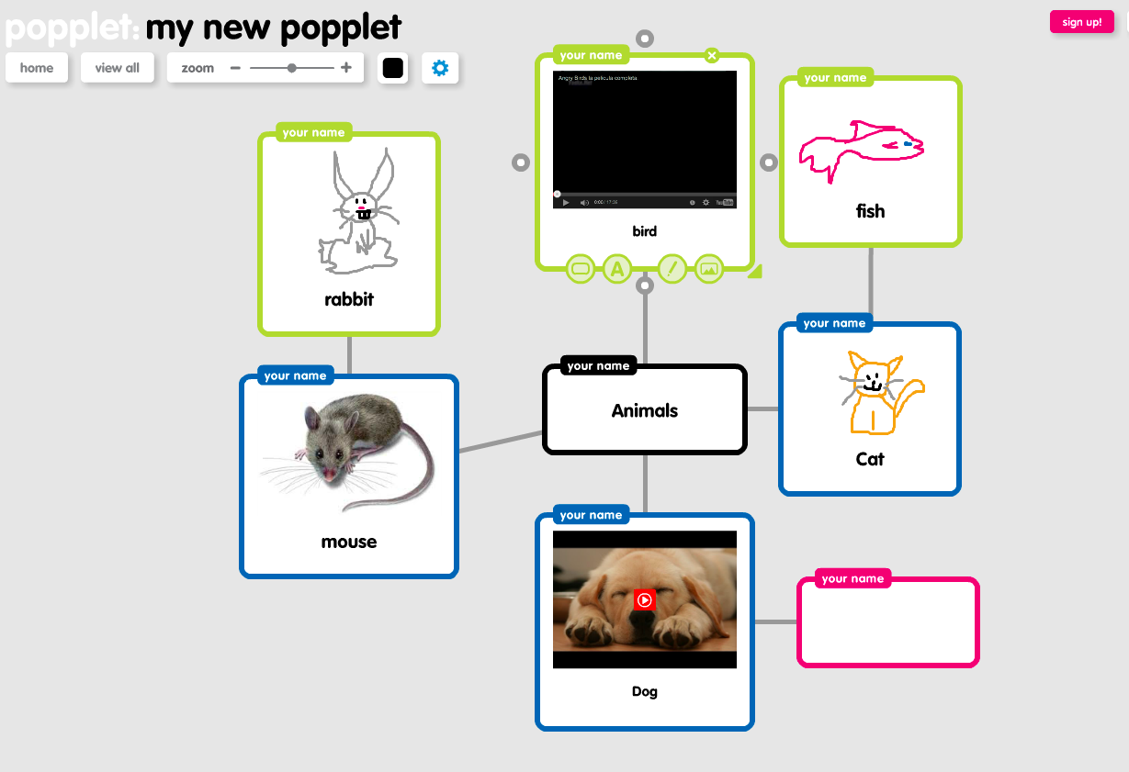
Songs from Super Simple Songs YouTube channel:
Walking in the jungle https://www.youtube.com/watch?v=GoSq-yZcJ-4
The animals on the farm https://www.youtube.com/watch?v=zXEq-QO3xTg
I have a pet https://www.youtube.com/watch?v=pWepfJ-8XU0
Let’s go to the zoo https://www.youtube.com/watch?v=OwRmivbNgQk
Android Application
Learn Animal Names in English https://play.google.com/store/apps/details?id=com.muratos.learn_animals_english
Animals for kids
https://play.google.com/store/apps/details?id=gr.blogspot.feasyapps.animalsforkids&hl=en
Fun English Learning Games
https://play.google.com/store/apps/details?id=com.pumkin.fun
Animal Sounds with Pictures
https://play.google.com/store/apps/details?id=com.teachersparadise.animalsoundspictures
Pre-school zoo
https://play.google.com/store/apps/details?id=com.mafooly.preschoolzooanimals&hl=en
Com-phone: a multimedia video maker
https://play.google.com/store/apps/details?id=ac.robinson.mediaphone&hl=en
Online games
http://www.literactive.com/Download/live.asp?swf=story_files/match_the_sounds_US.swf
https://www.babytv.com/learning-centre-animals.aspx
http://learnenglishkids.britishcouncil.org/en/
http://www.sheppardsoftware.com/preschool/animals/farm/animalfarmgame.htm
http://matchthememory.com/create -- teacher create an online memory card

